

December 2019
Analytics Platform
MFT Access
Documentation Guide

Introduction
The following is a general description of how the end-to-end MFT process works in order to upload client data and consume model outputs that the Non-life Analytics Platform has prepared for the client in the form of flat files.
MFT / SFTP and Connect are different environments that use a common user management. The usernames for Connect and MFT are different. While both have a web interface, MFT allows programmatic access via SFTP. Connect however, is a Munich Re’s exclusive client portal which provides expert guidance, specialist tools and the latest insurance market news and information through fast, reliable and secure communication channels.
Confidentiality
All data submitted to Munich Re is subject to confidentiality. Results derived from the data will be communicated to the client.
Protection of Personal Data - Privacy
Please ensure that the data does not contain any personal information identifying individuals beyond what is required in the use cases and defined in the accompanying Data Exchange Requirements document.

Connect registration
Connect contract
First, please await a Welcome E-mail from the underwriter / customer manager, in which a Connect contract is attached. This contract should be read, signed and then returned.
DMZ client user and folder structure for our Non-life Analytics project creation
Secondly, after receiving the signed Connect contract, the underwriter / customer manager will send an E-mail to the connect Business Service and Global File Exchange Team to request for a DMZ User creation, as well as to ask for a folder structure creation for the Non-Life Analytics Project in the SFTP environment. This allows client data to be transmitted to Munich Re, and model outputs from the Non-Life Analytics Platform can be received by the client.
More information, such as how to transmit data by using the MFT portal, can be found in the accompanying Data Exchange Requirements document.
connect.munichre Access Agreement
After these steps have been completed please await an E-mail requesting you to accept the connect.munichre Access Agreement by clicking on the attached link. This will enable your permanent and free-of-charge use.
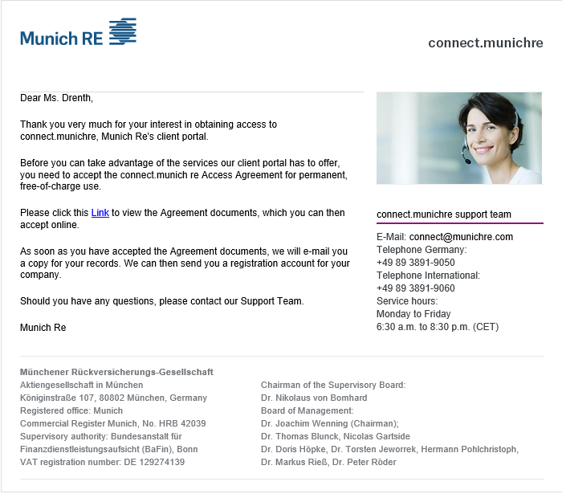
Photo 1: Access Agreement for connect.munichre E-mail
Personal login data
After accepting connect.munichre Access Agreement, you will receive an automatic E-mail with personal login data, username and password to the connect portal. (Link: connect.munichre.com)
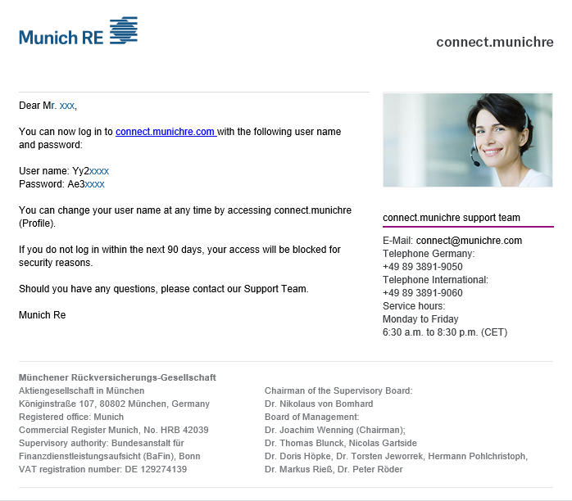
Photo 2: Personal login data E-mail

MFT registration

Pre-production environment
The MFT portal, a secure SFTP solution provided by Seeburger (Link: https://mr-eai-mft.munichre.com/portal-seefx/login.jsp) will allow data to be transmitted to Munich Re. The required credentials and the connection details will be provided per email.
To protect data privacy, you will first receive login data to our pre-production (PRP) environment (Link: https://mr-eai-mft-pprod.munichre.com/portal-seefx/login.jsp), whose interaction is similar to the production (PRD) environment, however, does not contain any real data. In order to subscribe to the Munich Re folder, please follow these three steps (see photos below).
- Step 1: choose “Please accept the General Informations” OK
- Step 2: click on Subscribe
- Step 3: tick the box under Subscribed, then click Close

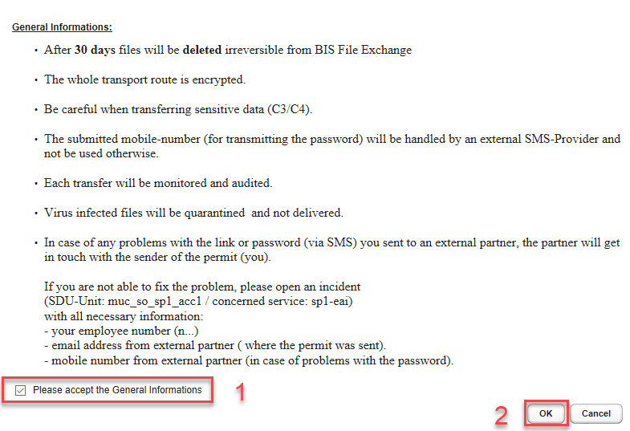
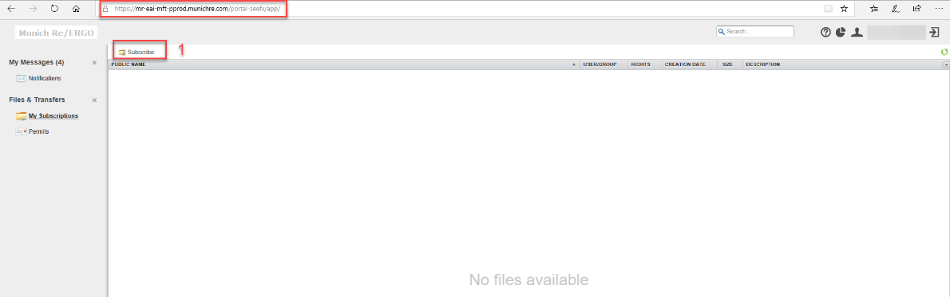
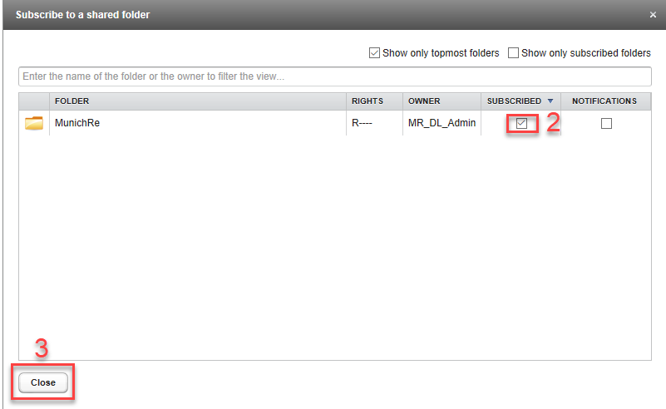
After subscribing to the MunichRe Folder, you will be asked to take a screenshot of your interface and send it to Stephan Anné, SAnne@munichre.com, so that we can make sure the data privacy is protected (please see screenshot below).
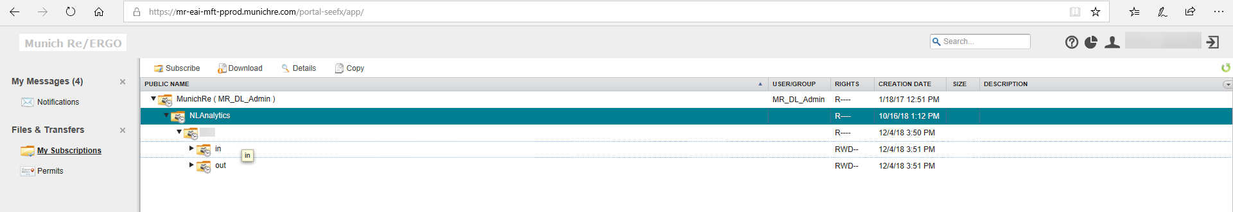
Photo : Screenshot

Production environment
After being sure that the data privacy is protected you will receive an E-mail which confirms your access to our Production environment (Link: https://mr-eai-mft.munichre.com/portal-seefx/login.jsp). To subscribe to the MunichRe Folder, please follow the same three steps as used in the pre-production environment (see photos).

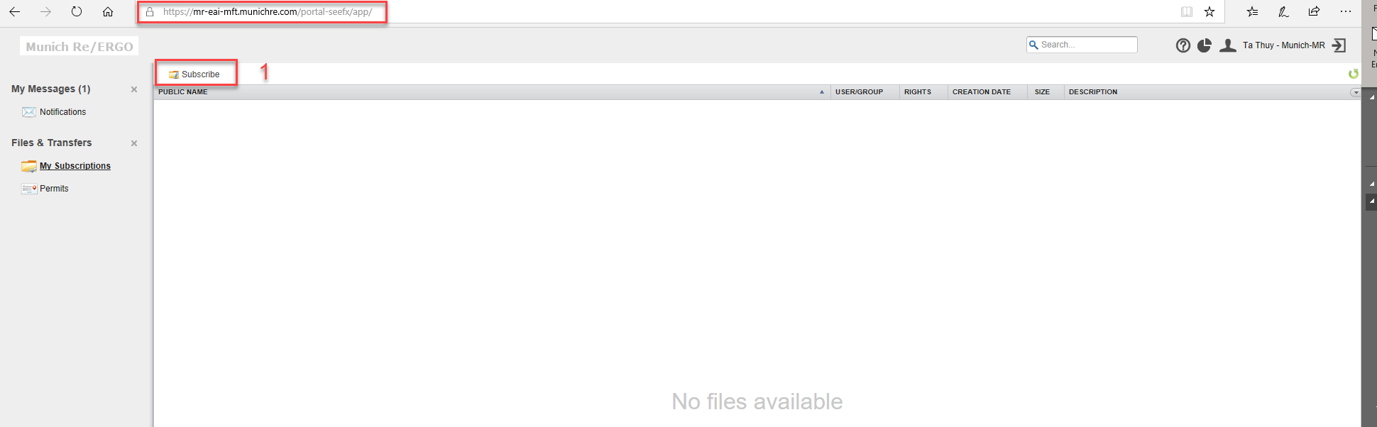
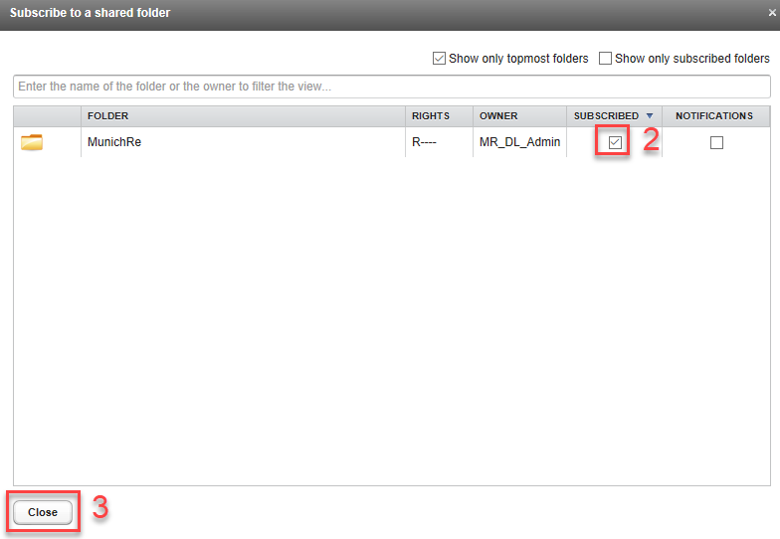

Password change request
It should be noted that the password must be renewed regularly, every 90 days for the Connect, and every 60 days for the SFTP. You will receive a message when connecting to Connect prompting you to change the password. Please keep in mind that no further reminder emails will be sent prompting you to renew the password.
SFTP-Users are required to remember to renew their password after the login-day. The Connect link is used to login in to SFTP and also to renew the SFTP password.
IMPORTANT: If the password renewal is forgotten, change it using the <user> email address on connect.

Subscription of Folder structure
The folder structure is already pre-configured and can be used for all file uploads and downloads. Standard folder structure is as follows
<Customer-Name>
\In
\Out
Underneath “In” and “Out” the parties agree on sub-folders per transferred table structure, where each folder corresponds to one table; see example below.
Access via command-line interface sftp is possible. An example is listed in the following paragraph:
sftp -b >batchfile> <user>\@MRW2KDMZ.com@mr-eai-mft.munichre.com
Please be aware that you have to mask the @ symbol in the username.
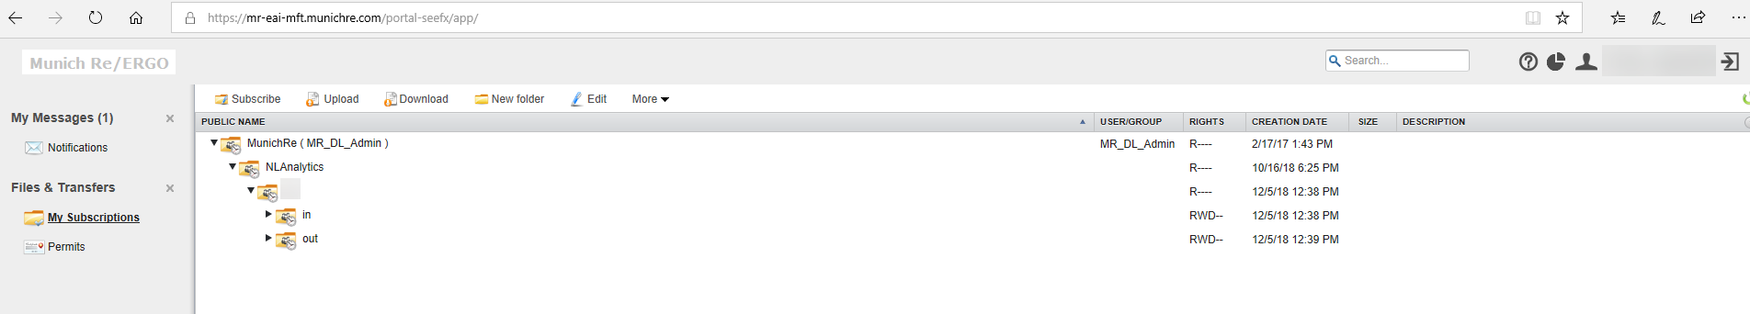

Size limitation of uploaded file
There are no size restrictions for the MFT-Tool itself. The limiting factor (4 GB) is the Browser (Browser http Transfer restrictions) for http transfers. With fixed partners you can exchange data via SFTP up to 60 GB. Bigger file sizes are not recommended with regard to our network as it results in files being corrupted . Transferring files ~ 60 GB takes 8h minimum. In case network issues during this time the transfer will stop and must be restarted.

Contact
For questions, comments or issues please reach out to us via E-mail to p0060005827@munichre.com.

© 2019
Münchener Rückversicherungs-Gesellschaft
Königinstrasse 107, 80802 München, Germany
Picture credit:
Dan Tobin Smith/ArtPartner
Münchener Rückversicherungs-Gesellschaft
(Munich Reinsurance Company) is a reinsurance
company
organised under the laws of Germany.
In some countries,
including in the United States,
Munich Reinsurance Company holds the status of
an unauthorised reinsurer. Policies are underwritten
by Munich Reinsurance Company or its affiliated
insurance
and reinsurance subsidiaries. Certain
coverages
are not available in all jurisdictions.
Any description in this document is for general
information purposes only and does not constitute
an offer to sell or a solicitation of an offer to
buy any product.

